**SUPPLEMENTAL MEMO**

DATE: June 19, 2020

TO: Mayor, Council President and Councilmembers, Taskforces,

FROM: Tim Johnson

SUBJECT: Impact of COVID-19 on Professional Sports: Seahawks, Sounders, Mariners & More

This week’s supplemental focuses on the impact COVID-19 has had on professional sports and our region’s pro teams. Baseball and the hope of the first pitch of opening day still beckons. Our human psyches plead for it. It is our national game even if we will not be able to attend in person. So, we wait, along a continuum of patience for the return of the boys of summer. In the meantime, the revenue coupled with the economic loss are significant. Hopefully, the umpire’s phrase- “Let’s Play Ball,” is soon to occur. Until then, we share with you the following insight.

BACKGROUND

Professional sports in the United States are a cultural cornerstone of society. It is not surprising to identify it as a multi-billion dollar industry.

Professional sports have a broad reach. As of 2019, 49 metropolitan areas (42 in the U.S., seven in Canada) have at least one team in the National Football League, Major League Baseball, National Basketball Association and the National Hockey League.

According to the federal government’s Bureau of Labor Statistics, there was 13,500 professional athletes and sports competitors in 2018. However, the indirect number employed to present such events or competitions is significantly higher with some estimates placing it in the millions. Additionally, the monetary value of professional sport franchises in 2018 had a value of about $71 billion U.S. dollars. This figure is expected to rise to $83 billion by 2023.

The market is comprised of gate revenues, media rights, sponsorships and merchandising. In 2018, some $19.2 billion U.S. dollars in revenue were generated through ticket sales alone. However, the largest revenue stream in the US sports market is the media rights market, where revenue is generated from fees paid by radio, television or internet broadcasters to distribute sporting events.

Due to the wide availability of media devices, this sector has increased tremendously in size in the past ten years, from $8.5 billion U.S. dollars in revenue in 2006 to just over $20.14 billion in 2018.

Meanwhile, the sponsorship sector, which includes revenues generated by payments from companies to have their products associated with an event, a team or a league, has also been expanding in the past years. In 2018, an estimated $17 billion in U.S. dollars were generated through this channel.

The merchandising sector, which includes everything from team jerseys to branded sports equipment, has seen slow but steady growth and was estimated to be around $15 billion in 2018.

IMPACT OF COVID-19

In response to the COVID-19 pandemic, most major professional sports leagues in the U.S have either postponed their seasons to a new date or a date that is not yet determined.

The direct potential economic impact from these changes in the form of wage loss is quite simple to identify.

Estimates suggest that about 1.3 million sports jobs face a risk of being furloughed, reduced, if not even erased. This translates to a potential wage loss of about $12.3 billion by the end of June. Jobs likely to face the brunt of this crisis are coaches & scouts, fitness trainers and stadium attendants, and concessionaires because they account for some of the highest number of sports related jobs. Together, these occupations comprise nearly a million jobs. But a huge variety of sports occupations—from umpires, referees to locker room attendants are also affected.

It is important to note that raw earnings for athletes & sports competitors themselves ($349M) are lower than you might expect, because this salary figure includes only wages from contracts. However, don’t feel bad, as most high-paid athletes make more from endorsements than from their actual salaries.

When it comes to occupations supporting professional sports, it is millennials who are most affected. Millennials aged 25-34 are sports’ largest employed group, making up 23% within the sector while, older millennials, and Gen X ages 35-44, make up 16%.

Meanwhile, professional sports face a daunting list of structural challenges that they need to overcome in their quest to eventually return to “normalcy.” For example, each sport monetizes differently, but the general principle is that the organizing body distributes its total income between its participating clubs, teams or franchises. The collective power of these leagues is to sell media rights (which is a primary source of revenue) and it is incredible amount. The following table illustrates the magnitude of the income.

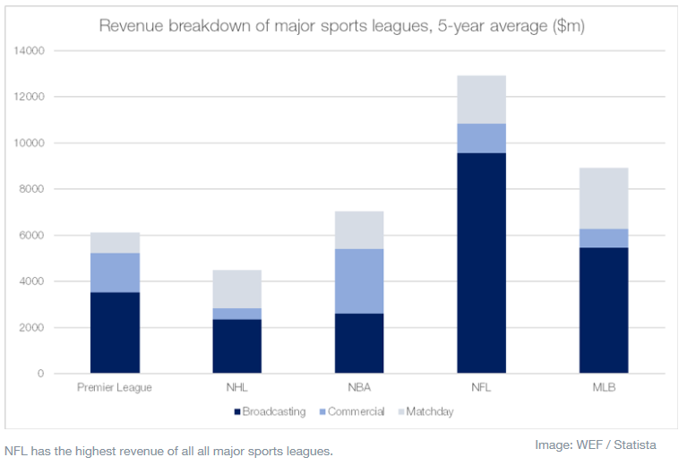

For example, the NBA’s current nine year TV deal is worth $24 billion through 2024-2025 season. The NFL receives $3 billion a year from multiple networks. However, over recent years people have sharply shifted the way they consume sports content from cable and satellite television to online sources. Coupled with the COVID-19 effect, it has changed consumption patterns. Because of these changes, it may limit the leagues abilities to fully recover potential income providing it back to the clubs, teams or franchises.

INDUSTRY RESPONSE

However, the lockdown from the coronavirus has driven consumers to viewing more media than ever. As such, there are efforts from the industry to monetize this consumption by deepening the pool of content available to fans. For example, sports networks such as ESPN and Fox Sports are showing classic games, archived content, documentaries, e-sports and niche competitions in a bid to keep consumers watching until the big four leagues return.

Meanwhile, the National Football League, NFL is making every game since 2009 available for streaming on its direct-to-consumer channel - Game Pass. The strategy has led to a 500-fold increase in daily sign-ups for the service. Moreover, the industry is expected to adapt to the times by making payment options more flexible.

The National Basketball Association, NBA and Turner Sports have removed the paywall for their joint streaming subscription service, League Pass. Major League Baseball, MLB is doing the same, offering its archive of games for free on MLB.TV and YouTube. These actions are all intended to keep the spectator- fan, and with the hope to offset the lost revenue from the broadcasts created by COVID-19.

Finally, leagues are renegotiating their terms of service with networks and broadcasters to include paying compensation, granting additional rights, and extending agreements. Many leagues are developing tentative plans for games without live audiences to realize these revenues. Major League Baseball may possibly mirror Japanese pro baseball. For example, Japan’s baseball teams played in empty stadiums for weeks. Options also include playing matches in areas less affected by COVID-19 and moving training facilities – and even isolating entire teams and their management staff to a single area.

INDIRECT IMPACTS AND CAVEATS

To quantify the true impact on the American and Puget Sound economies, it is also necessary to account for the damages to the peripheral services that rely on sports. This includes restaurants, bars, vendors, security personnel and so forth.

Patrick Rishe, who directs the sports business program at Washington University in St. Louis estimates that the crisis stands to wipe out more than $3.25 billion that fans would have spent on pro sports. Separately but also impactful, outdoor recreation generated $427 billion in 2017, according to the Bureau of Economic Analysis. Sporting goods stores, golf courses and fishing tournaments shut down in parts of the country, those revenues and jobs have disappeared, too.

But back on point, research indicates that property values and rents for businesses in locations with sporting and athletic venues (professional or college) are higher because they are perceived to bring in more foot traffic which offset higher rent. However, due to the closures of these sporting venues, these businesses have lost significant revenues while they still face premium rents.

WASHINGTON

Quantifying this economic impact arising from professional sports is difficult. Money that is being spent on sports that otherwise wouldn’t have been spent at all is more beneficial to the economy than money spent on sports that was redirected away from another business.

In the case of a professional sports franchise, the economy is benefiting from the spending of the away team’s players and fans in their local economy that would not have happened otherwise. The economic concept of leisure substitution claims that since most consumers have a relatively strict leisure budget, money that is spent on going to a sports game is not additional money, but rather money that is not spent on other leisure activities. However, it is of little consolation given that competitive activities for that money are also closed.

Savings is another important economic impact. The majority of revenue generated through professional sports goes towards the players and owners. They are usually in the top tax bracket, meaning that over 40 percent of their income goes directly back to the government. Additionally, high income earners tend to have a higher savings rate, which pulls money out of the economy and detracts from the GDP of the region.

However, the clubs, teams or franchises do hire middle income employees that do put money into the economy and impact positively the GDP of a region. The average annual revenues for professional sports teams are $155 million for the NFL, $130 million for MLB, $95 million for the NBA and $70 million for the National Hockey League, NHL.

The Seattle Sounders for example, is estimated to be the third most valuable franchise in Major League Soccer, MLS. So their revenue is estimated to be significantly higher than the average. However, MLS is not spared from the impacts of COVID-19. MLS announced that it cut the salaries of most of its headquarters employees by as much as 25% due to the impacts of the COVID-19.

Meanwhile, the NBA cut the salaries of some 100 top executives by 20% while the season remains on hold. The NHL has also cut salaries for its league employees by 25% in the hope that some cost cutting measures now will prevent future layoffs. Auto racing’s NASCAR has reduced its officers’ salaries by 25%, as well while all other employees will have their salaries reduced by 20%.

These leagues or sanctioning bodies’ decisions are bound to trickle down to the individual teams. The good news is that several studies have indicated that temporary suspensions of sporting events has no observed positive or negative effects on the local economy when measuring per capita income and unemployment. A significant number of jobs provided by teams are often part-time work that only occurs several months during the year and only serve as a temporary income source to supplement existing income. As a result, the workers who already have jobs and work at the stadiums in their free time will not show up in the unemployment numbers because they have only lost some supplemental income, not their primary revenue stream. To combat this issue however, each Major League Baseball franchise including the Mariners pledged $1 million to support ballpark employees in March. However, the Mariners went further by creating a fund through their Mariners Care 501 C (3) non-profit. It will pay about 1,100 event staff workers through a needs-based grants program during the shutdown.

However, given the temporary and part-time nature of these jobs and the impact resulting from COVID-19, this suspiciously straightforward employment data is like a ghost, it may not appear in any government labor report. Depending on the nature of the sport and the franchise, those that work game days could work for either the team directly or through a management company that contracts with a pro team(s) and stadium(s) to provide such services as concessions. Some may qualify for unemployment, while others may not. In either case, it is important to note that temporary or otherwise, lost income is still a hardship on an individual level and tends to impact different demographics differently.

CONCLUSION

It appears that no professional sport is spared from COVID-19. This is not like a labor strike, or a natural disaster impacting a geographical area. All owners, athletes, coaches and fans are impacted.

Professional sports are a cornerstone of the American psyche. It is a national pastime that millions of people benefit from in the form of community building. Indeed, professional sports is a means of catharsis from the stress and gravitas of everyday life. This makes the recent cancellations and delays more of a psychological issue than an economic one.

Beth Knox, President and CEO of the Seattle Sports Commission offers’ a straight forward opinion to the value of sports. “The sports industry will play a critical role in our region’s recovery and future resiliency as fans return to stadiums and experience the shared community pride generated by a love of sports.”

As this article has tried to delineate, the exact economic impact on local economies from the postponement of professional sports is not only unclear, but maybe not as significant as closures of other sectors of the economy. Regardless, one thing is for certain, millions of people across the country are patiently waiting for sports to make a dramatic comeback to lift up their spirits and provide a glimpse of normalcy in these very trying times.

_____________________________________________________________________________________

Soham Ghose is a graduating senior in quantitative economics at the University of Washington. Soham is an economic development intern for the City of Federal Way. Soham was born and raised in Bangalore, India. He is fluent in Hindi, Bengali and English and has basic fluency in Spanish and French. He previously worked for Arab Financial Services in Bahrain. He will be pursuing a Master’s Degree in Economics at Western Ontario University in Canada.